Continuous Integration and Continuous Deployment Lab

Experiment 1

**Name – Harivansh Mathur**

**Roll No – R171218043**

**Installation of Jenkins and Execution of a simple job in Jenkins**

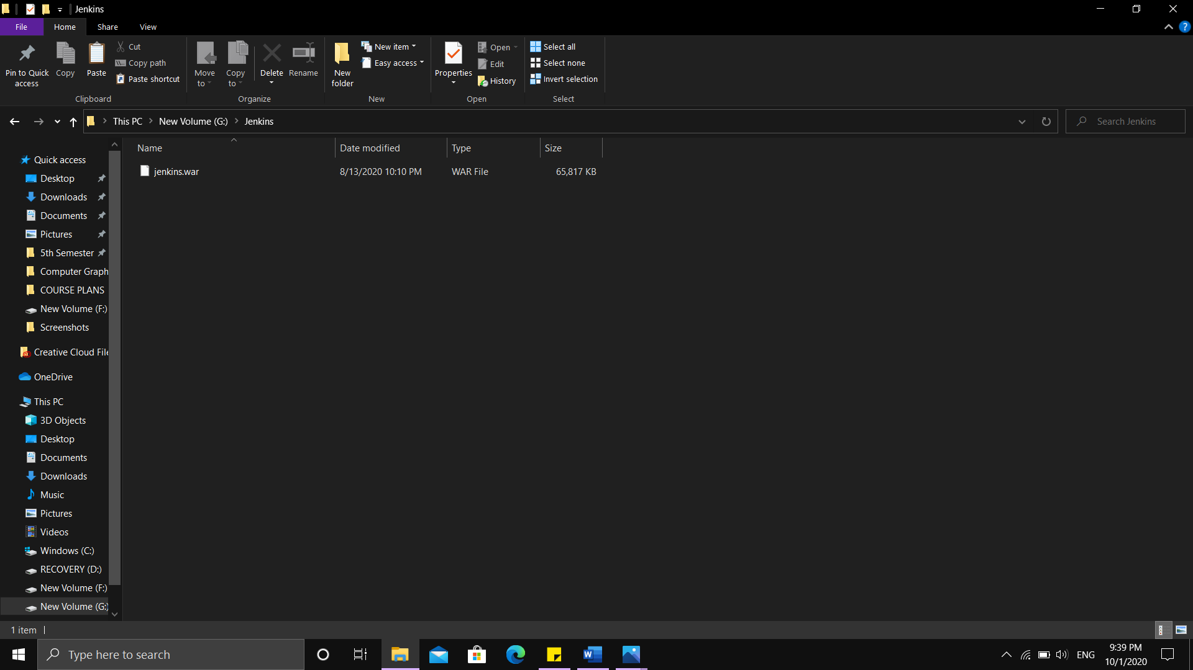

Downloading the .war file from jenkins.io and copying it in a separate folder

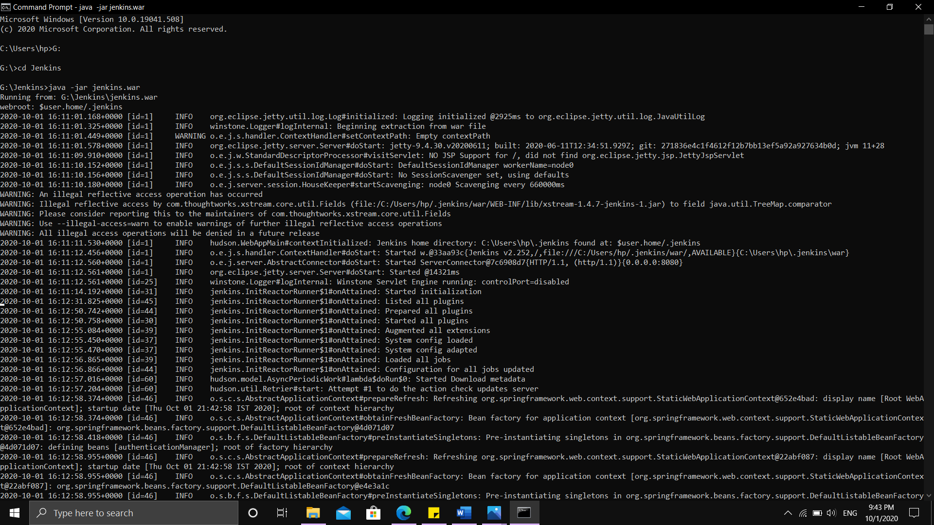

Opening Command Prompt and going to the directory where that .war file is placed and then running “java -jar jenkins.war” to start Jenkins

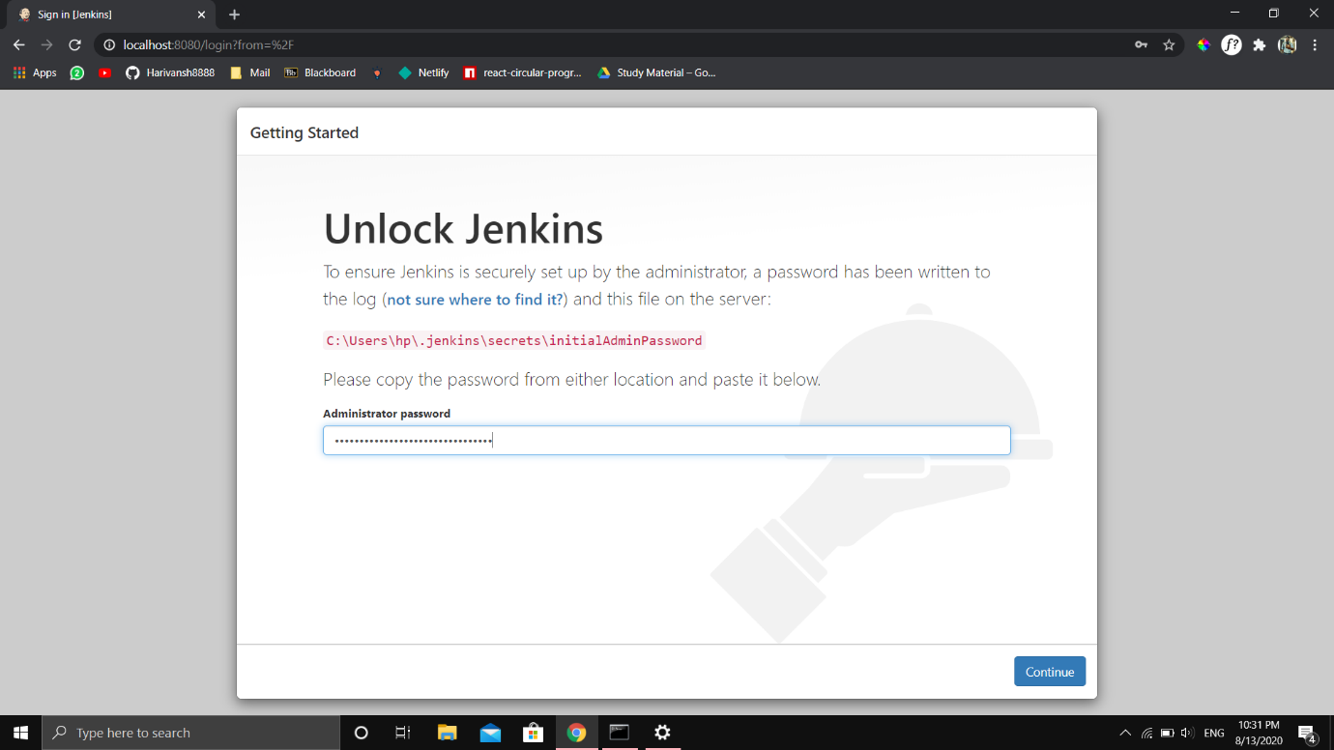

Entering the one time password on the first sign in

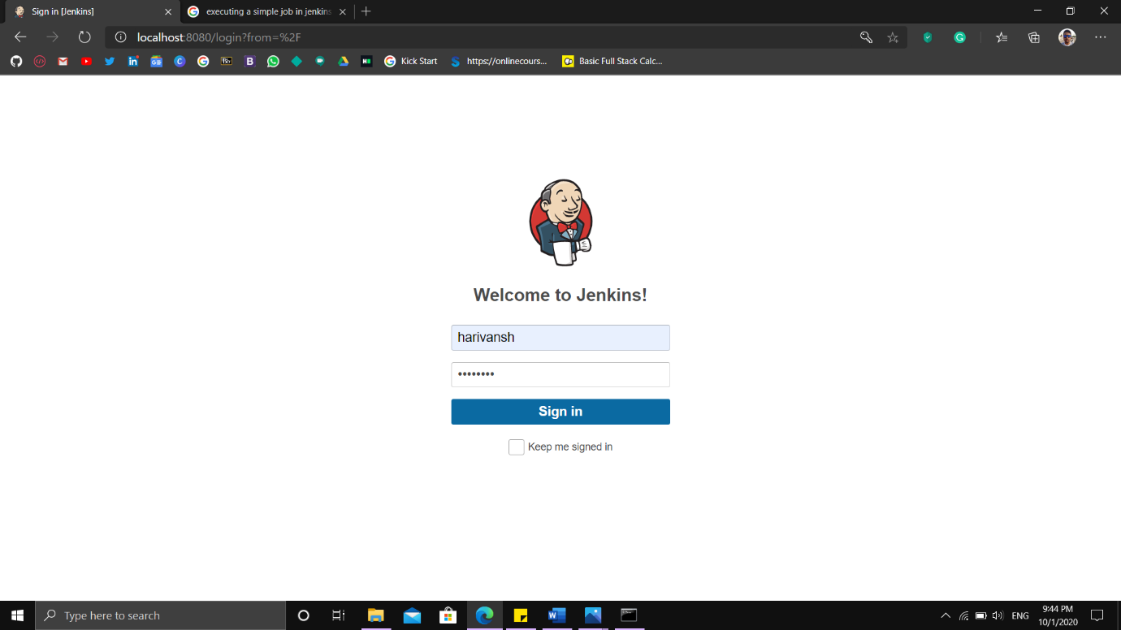

Log in Screen

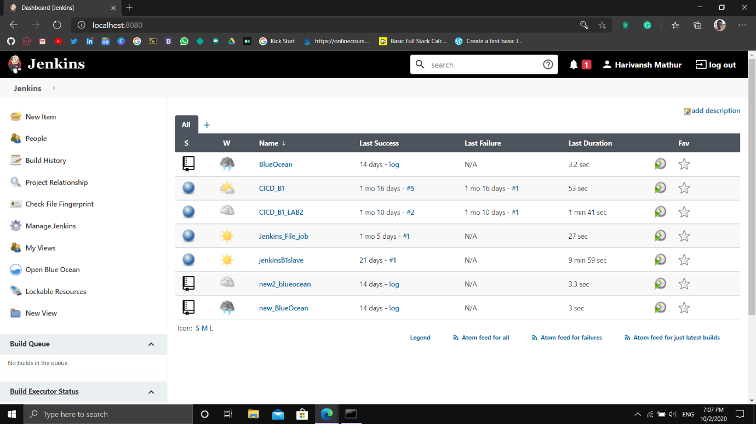

Jenkins Dashboard

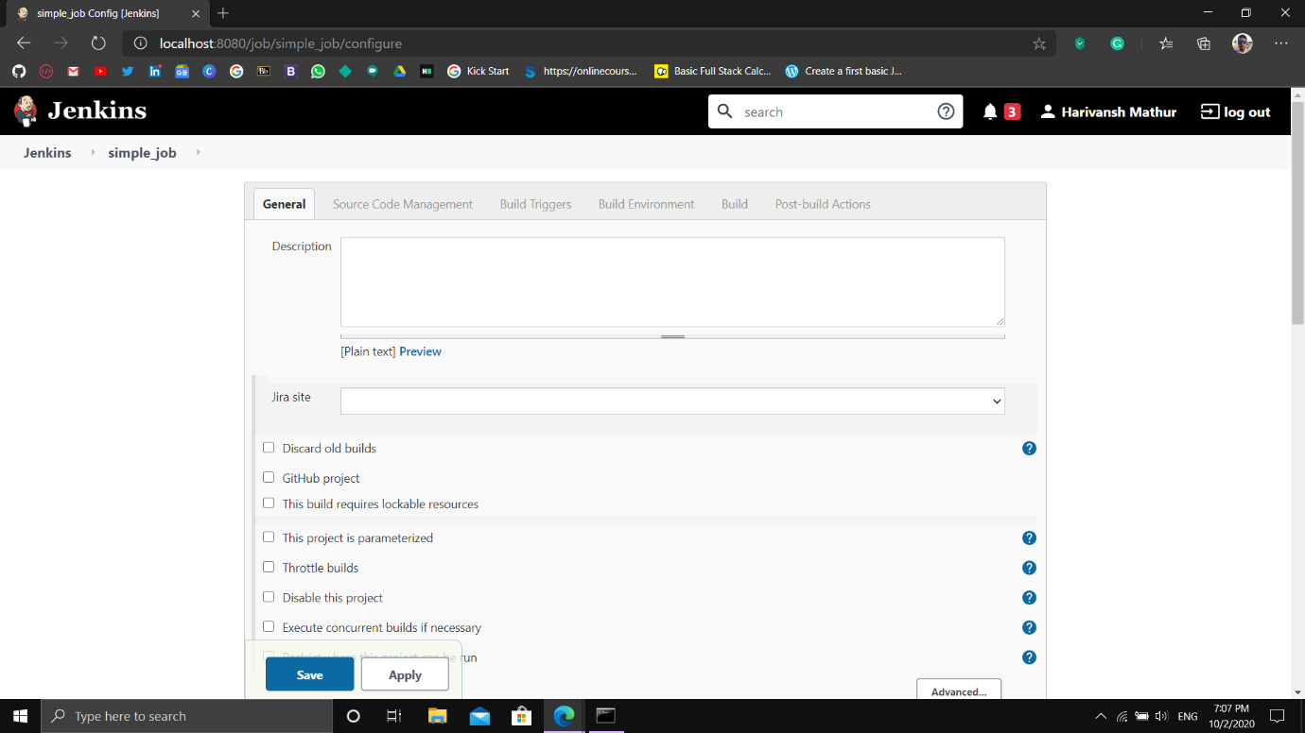

Creating a new freestyle project with the name “simple_job”

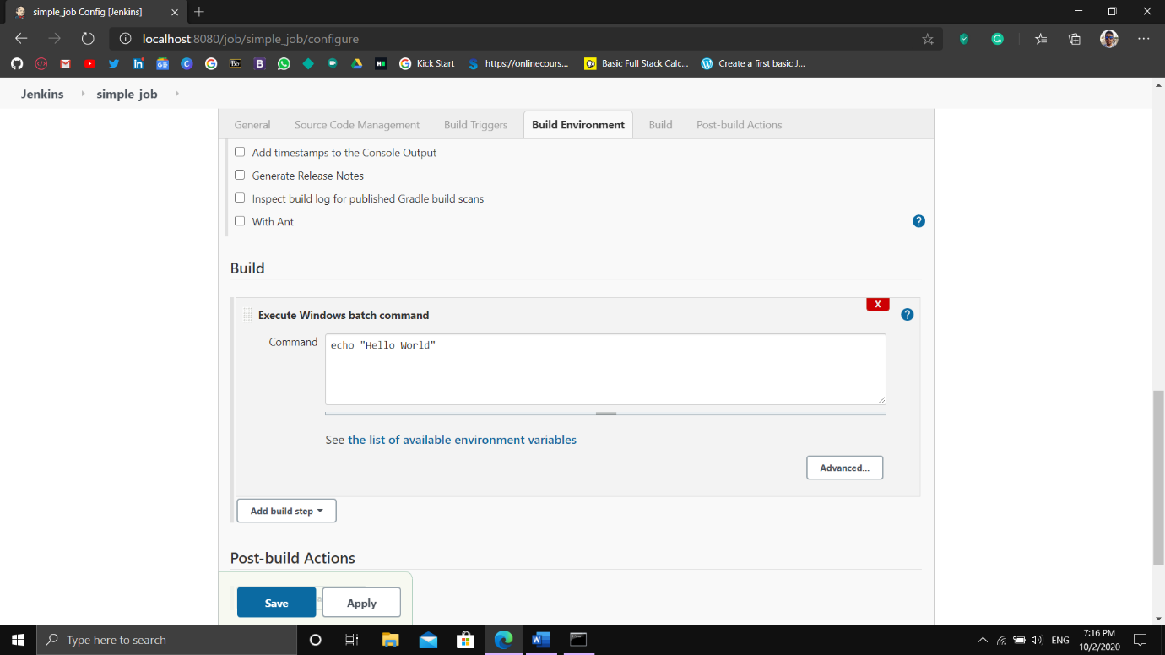

In Build option select to execute a windows batch command and using echo print “Hello World”

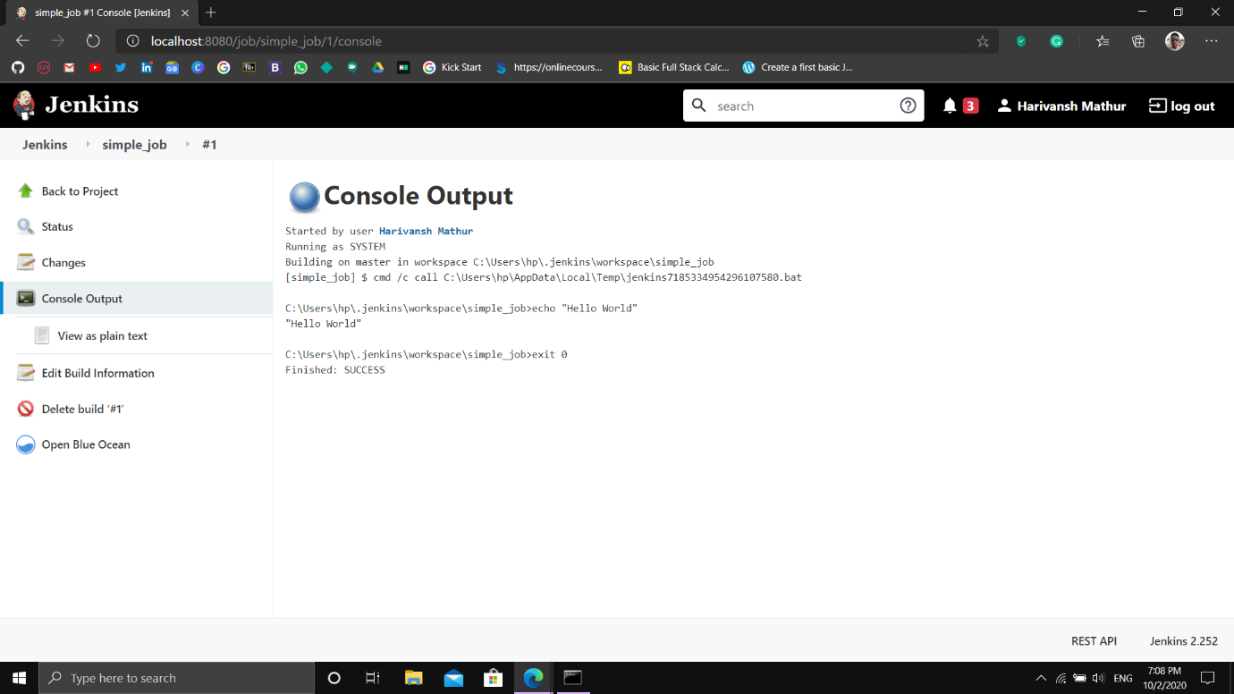

Build the job and the console output is displayed here